* **Null Hypothesis (H0)** – This can be thought of as the implied hypothesis. “Null” meaning “nothing.”  This hypothesis states that there is no difference between groups or no relationship between variables. The null hypothesis is a presumption of status quo or no change.
* **Alternative Hypothesis (Ha)**– This is also known as the claim. This hypothesis should state what you expect the data to show, based on your research on the topic. This is your answer to your research question.

**Examples**:

Null Hypothesis:  H0: There is no difference in the salary of factory workers based on gender.  
Alternative Hypothesis:  Ha: Male factory workers have a higher salary than female factory workers.

Null Hypothesis:  H0: There is no relationship between height and shoe size.  
Alternative Hypothesis:  Ha: There is a positive relationship between height and shoe size.

Null Hypothesis:  H0: Experience on the job has no impact on the quality of a brick mason’s work.  
Alternative Hypothesis:  Ha: The quality of a brick mason’s work is influenced by on-the-job experience.

**Two-tailed Test**

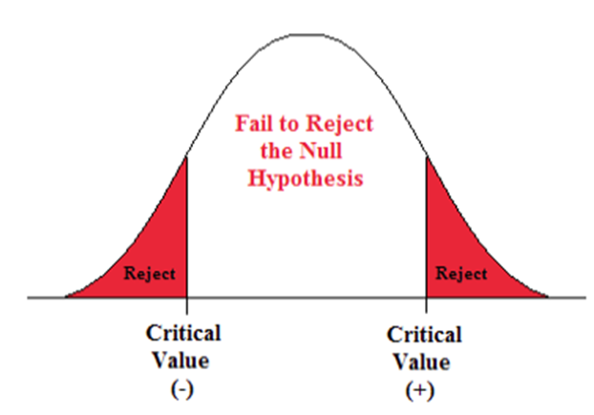

When testing a hypothesis, you must determine if it is a one-tailed or a two-tailed test. The most common format is a two-tailed test, meaning the critical region is located in both tails of the distribution. This is also referred to as a non-directional hypothesis.

Normal curve showing two-tails shaded in red

This type of test is associated with a "neutral" alternative hypothesis. Here are some examples:

* There is a difference between the scores.
* The groups are not equal.
* There is a relationship between the variables.

**One-tailed Test**

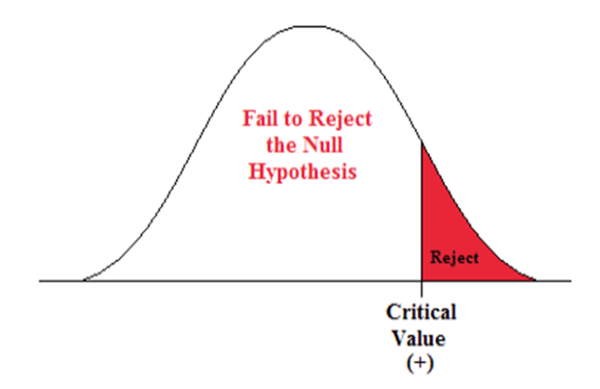

The alternative option is a one-tailed test. As the name implies, the critical region lies in only one tail of the distribution. This is also called a directional hypothesis. The image below shows a right-tailed test. A left-tailed test would be another type of one-tailed test.

Normal Curve showing one tail shaded in red

This type of test is associated with a more specific alternative claim. Here are some examples:

* One group is higher than the other.
* There is a decrease in performance.
* Group A performs worse than Group B.

One important part of hypothesis testing is understanding how to determine if there is enough evidence to support your claim. There are two possible outcomes of hypothesis testing:

* *Reject the Null Hypothesis*
  + Determine that there is sufficient evidence to suggest that the alternative hypothesis is true.
* *Fail to Reject the Null Hypothesis*
  + Determine that there is not sufficient evidence to suggest the alternative hypothesis is true.

**Note that when it comes to statistics, nothing is certain. Rejecting the null hypothesis does not “prove” your claim to be true, it simply provides evidence that suggests that it could be. Similarly, failing to reject the null does not “prove” that the null is true, the data simply just did not provide enough evidence to suggest the alternative is true.**

